**BIA 600: BUSINESS ANALYTICS**

**DR. BEI YAN**

**COURSE PROJECT**

**COVID-19 RESEARCH PROJECT**

Group 10

Aakash Rathod

Buddhaditya Rath

Rohan Birwadkar



**SCHOOL OF BUSINESSTEVENS INSTITUTE OF TECHNOLOGY**

**Introduction:**

The Covid-19 pandemic has been considered the most horrible pandemic in the world, which started in late December 2019. Covid cases have crossed the 270 million mark worldwide.

Amid the Covid-19 Pandemic, many countries started to take different measures in order to prevent the spread of covid, and minimize the impact. Patients were isolated, public gatherings were restricted, further lockdown was implemented, and vaccinations were provided as a safeguard for the public and to fight against the Covid-19 virus.

So were these measures efficient in protecting the countries against the covid pandemic? What effect did they have on the increasing numbers of cases and deaths around the world? Hence to further investigation, we will be looking into the two major measures taken during the covid pandemic, namely Lockdown and Vaccinations.

We will be taking a brief look over two Countries, India and Italy, to understand how these measures actually impacted over the course of pandemic. Italy’s Healthcare is considered to be one of the top quality health services provided in the world. But still, when covid-19 was emerged, italy became one of the worst hit nations. Especially considering the size and population of the country, its death toll is no. 8th in the whole world.

And in India, we will be looking whether imposition of lockdown and restrictions made any difference in the rising cases and deaths in the country. As there were several restrictions and lockdowns imposed in the country to preempt the sudden rise in covid cases.

**Dataset Explanation:**

Our dataset ranges from 1 January 2020 – 15th November 2021 and has approximately 130K records. This data set consists of the quantitative variables concerning their distribution. Statistical significance was set at p<0.05. This covid dataset is updated with the latest insight daily. It is an enormous dataset with an extensive set number of columns. For our research, we have filtered our data as per the requirement and have taken only selected columns of interest:

Country :-- It is a Categorical variable that holds the values of all the country names whose data is available. All the other columns contain the data about every country.

Date :-- Date as the name suggests is an Ordinal variable having the value of each day starting from January 01, 2020 and it is updated continuously everyday.

New_Cases :-- This column is a Ratio type which shows the count of cases that ruled out to be positive(infected) by Covid-19 on a particular day.

New_Deaths :-- It is a continuous ratio variable that indicates the number of casualties occurred at a particular date.

People_Vaccinated :-- It is a continuous ratio variable that indicates the number of people who have had at least one dose of vaccination up to a date.

People_Fully_Vaccinated :-- It is a continuous ratio variable that indicates the number of people who have had both the doses of covid vaccination up to a date.

Positive_Rate :-- Nominal field that shows the share of Covid 19 tests that come out as positive.

Infected_percent :-- Nominal calculated column that shows the percent of population that is currently infected by the virus.

Single_Dose_percent :-- Nominal calculated column that shows the percent of population that has been vaccinated with at least one dose of Covid vaccine.

Fully_vaccinated_percent :-- Nominal calculated column that shows the percent of population that has completed the vaccination or is fully vaccinated with Covid vaccine.

Population :-- It is a continuous ratio variable that indicates the population of a country.

The following table shows the Measurement Scales of the Dataset Columns:

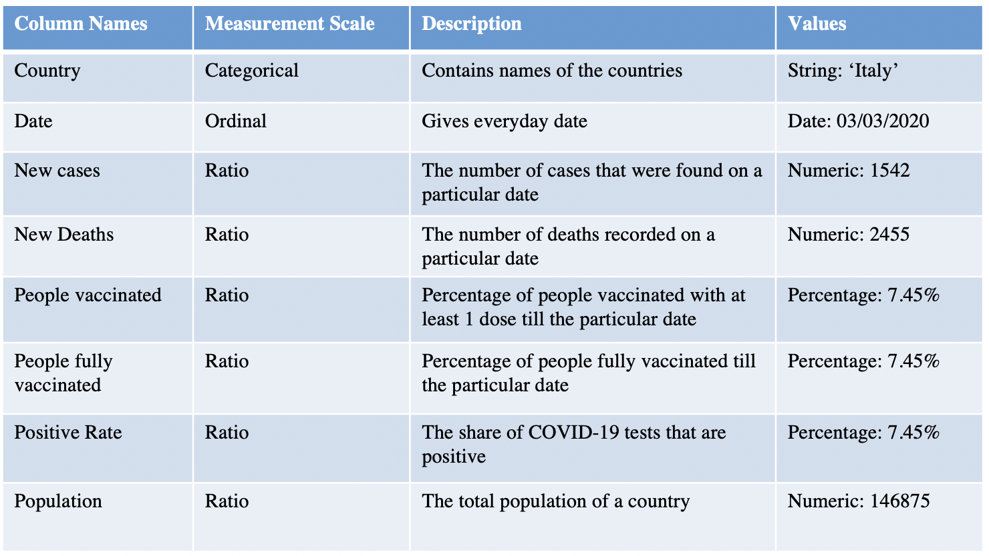

Visualization One: Covid 19 Case Map

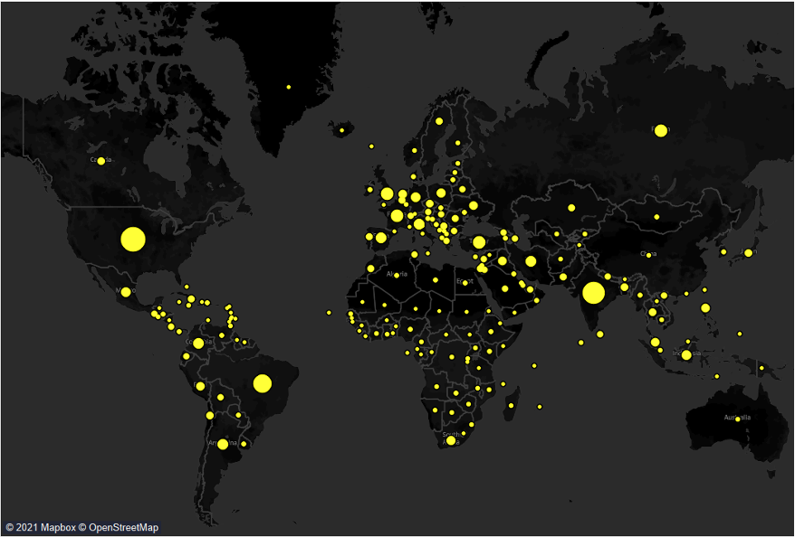

The above visual shows the map, where the circle in the visual depicts the countries that were infected by covid virus. And the size of the circle is proportional to the number of cases in that country.

From the visual we can identify that the United States, India and Brazil are one of the most infected countries. Also some European countries were heavily infected from covid virus.

Visualization Two: Countries with highest cases

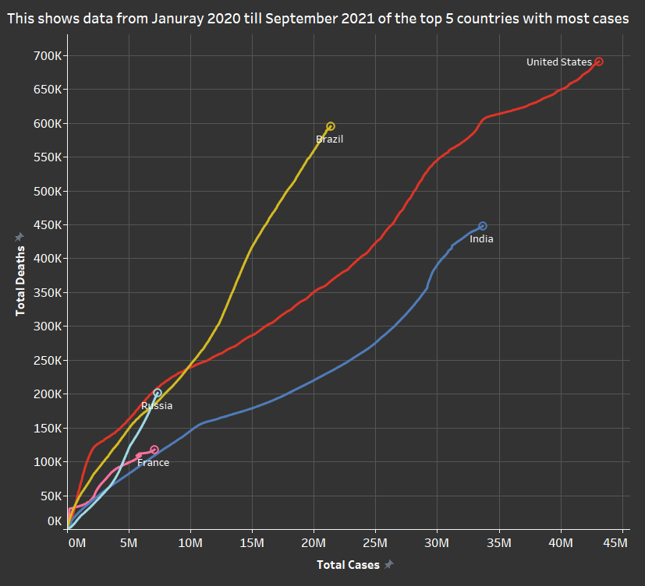

The above graph shows the top 5 countries with the most covid cases. It is easy to determine the pattern and rising trends of cases and deaths in each of these countries. We can see that the cases in Brazil were uprising quickly, with slower deaths. The United states had a steady increase in the number of cases and deaths as well.

**Analytics with Inferential Statistical Tools:**

Hypothesis Test 1:

Before we began the analytical process of utilizing inferential statistics to obtain answers, we compared the circumstances before and after vaccines began around the world. For this analysis, we will look at the country Italy. We selected the column ‘New_cases’ with data about the number of new cases reported on a daily basis. As vaccinations in Italy had already started in the beginning of 2021, we focused on data from the last 6 months of 2020 (i.e June to December) and first 6 months of 2021(i.e January to June).

The following table provides the key variables summary, where we can see that by the month of June, approximately 57% of the people were vaccinated with at least one dose of covid vaccine. Over the course of time, the positive rate was observed to be declining.

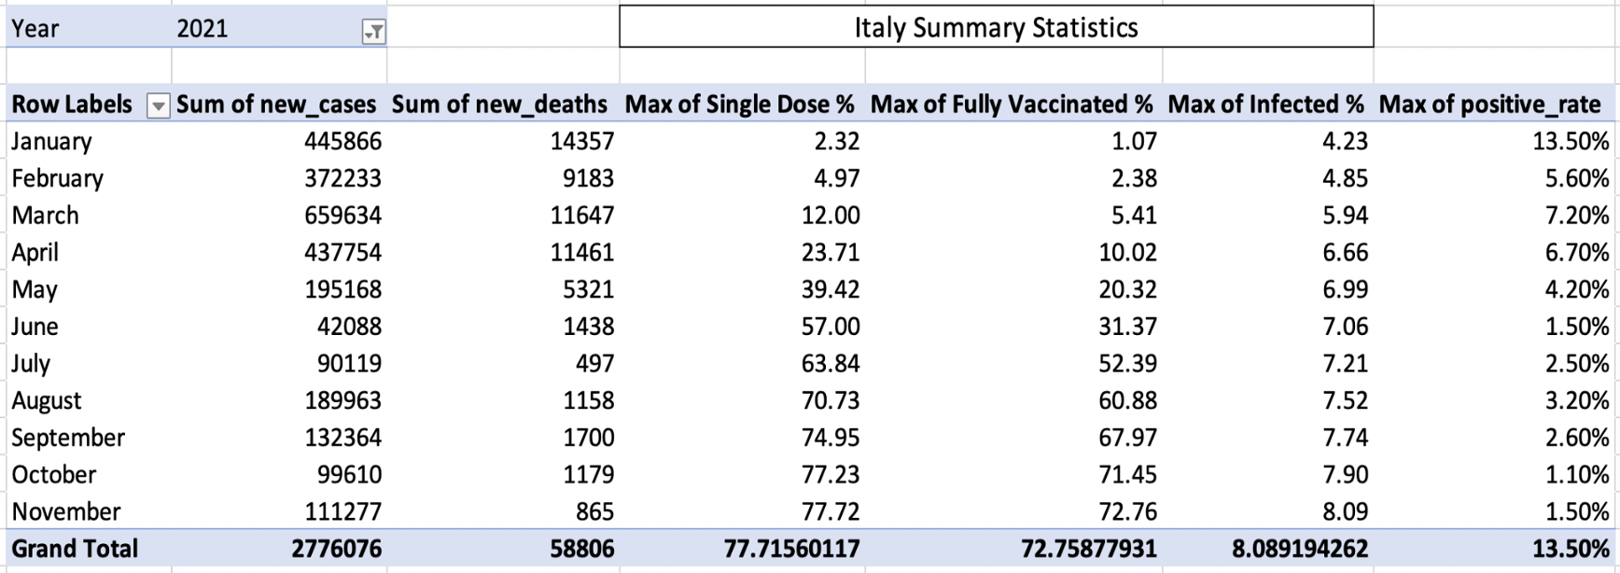

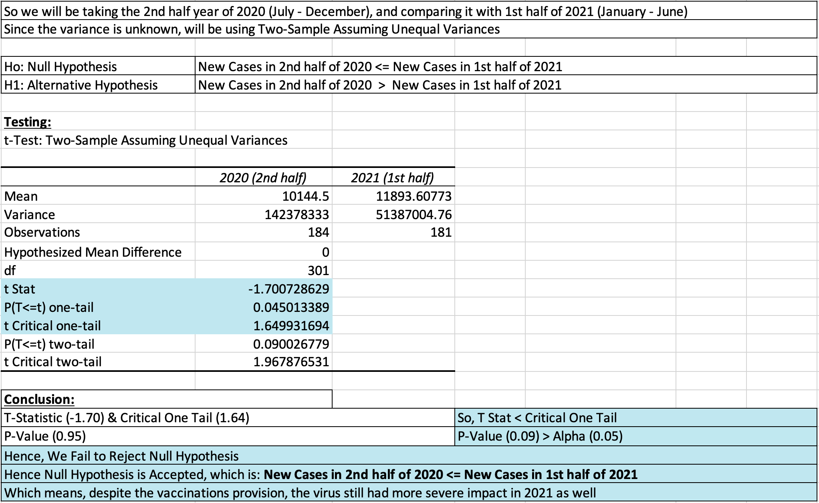 The failure to reject the Null hypothesis in the result suggested that more new cases were reported daily in the first half of 2021 than in the second half of 2020.

As a result, it raises the question of whether the precautions put in place to safeguard countries from the covid pandemic were effective, and if they had any impact on the rising number of cases and deaths around the world.

So, for a more in-depth examination, we compare the number of cases reported in the same first half of 2021, but this time in terms of Quarter 1 and Quarter 2.

Hypothesis Test 2: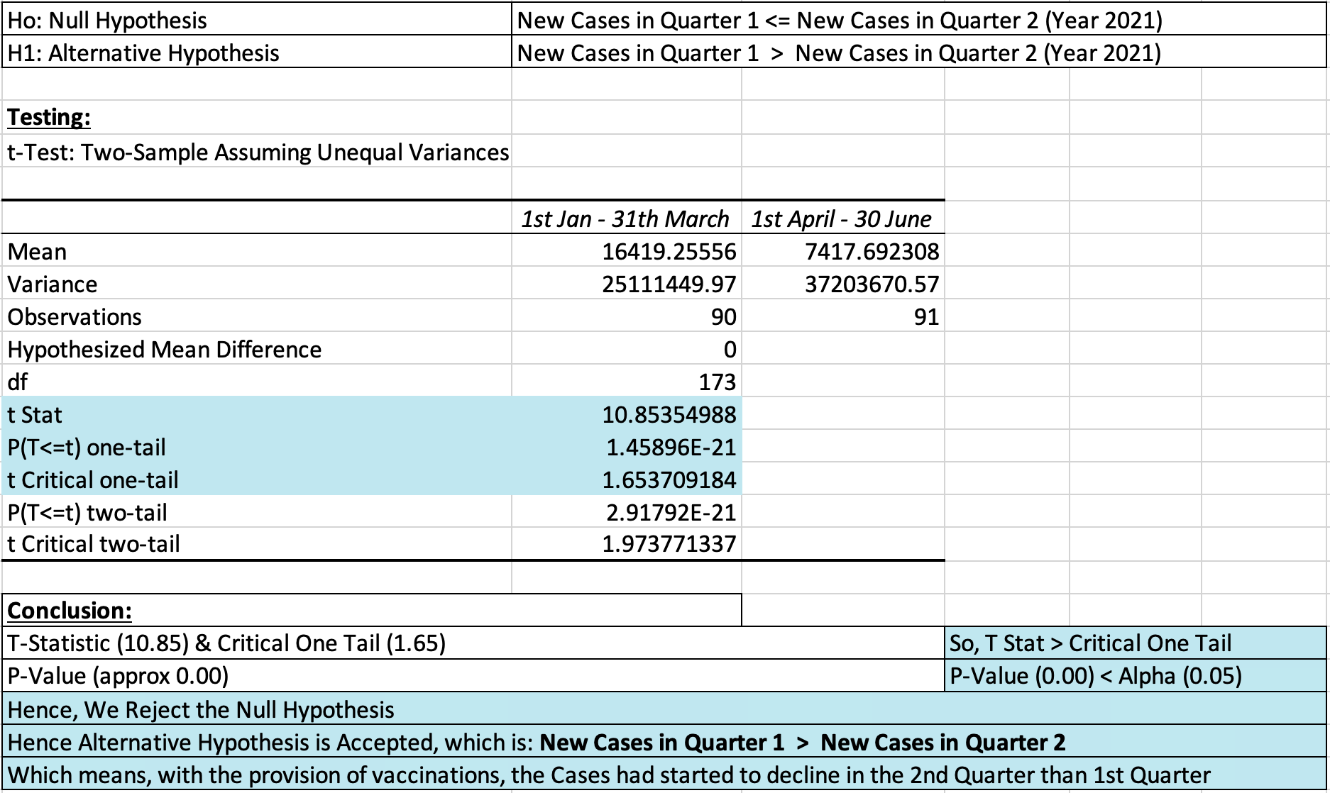

The Null Hypothesis is rejected in this case. This indicates that the number of cases decreased in Quarter 2 compared to Quarter 1. The vaccines that were carried out on a large scale in Italy did help in minimising the number of new cases in the 2nd Quarter.

We looked at the same time range to find out if there was any change in the number of deaths reported.

Hypothesis Test 3: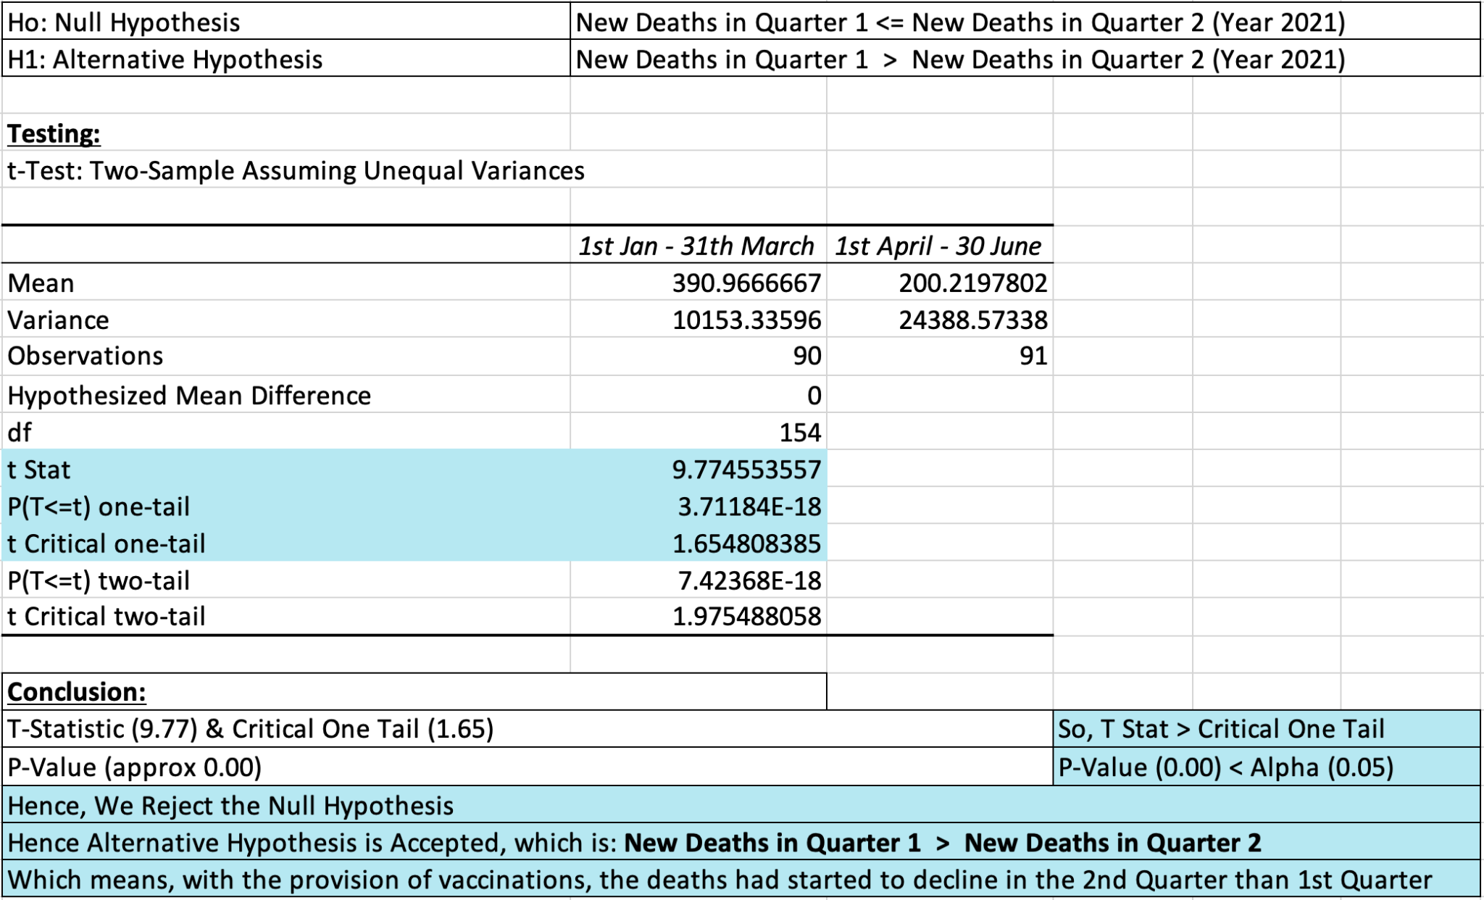

The Null hypothesis was rejected in this test, indicating that the number of deaths reported in the second quarter was lower than in the first.

Visual Analysis:

Below is the visual representation of the analysis comparing the vaccination percentage with the positive rate and also new cases and deaths reported over the span of the two quarters (Q1 & Q2)

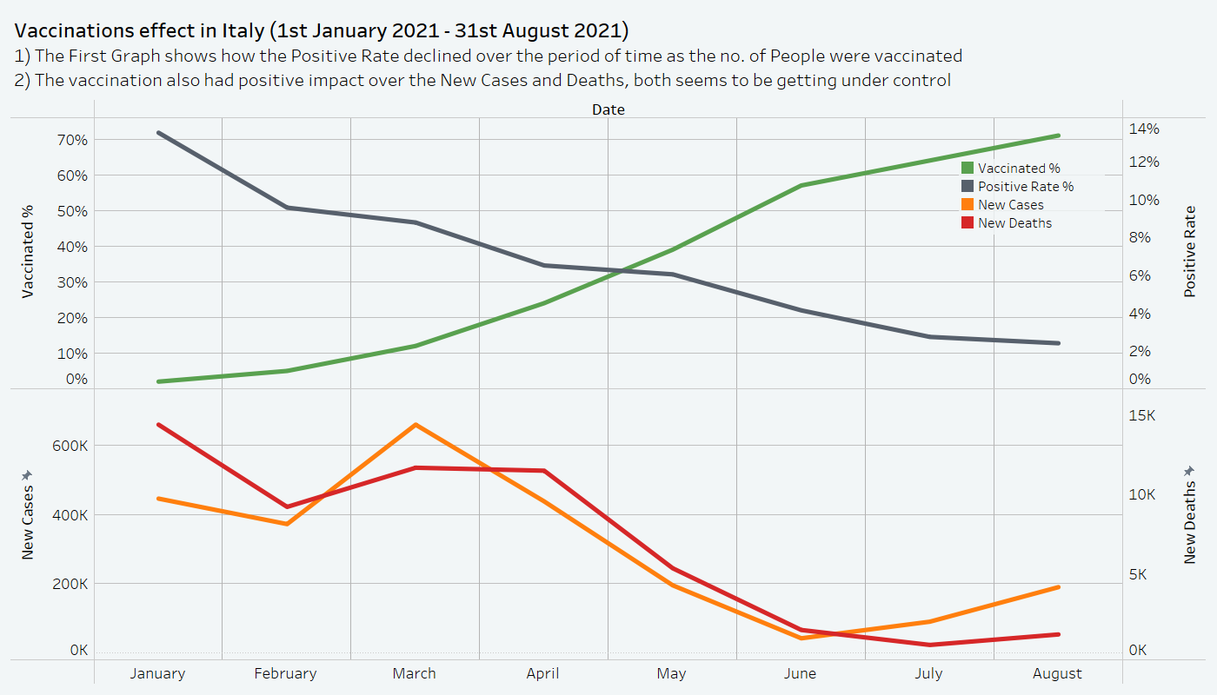

As visible above, until the end of the first quarter (March), the number of cases and the number of new deaths reported were on the rise. However, as the vaccination rate began to rise steadily at the start of the second quarter (April), the number of reported new cases and deaths began to fall. Positive rate also started to decline. This shows that in the second quarter, as a higher number of the population started getting vaccinated, the number of new cases and deaths being reported went lower. This reveals that immunizations performed a critical role in lowering mortality and the positive rate.

Lockdown Effect in India:

We will now look into whether the imposition of lockdown in India aided in the controlling and preventing covid-19. During the pandemic, India imposed two major lockdowns, each lasting three months. Thus, we will look at the three-month lockdown that took place in the year 2021 (i.e., from April to June) considering the most recent data that we can use for our analysis. So we will look in the year 2021 in India, and compare the Quarter 2 and Quarter 3 to help understand the after effects lockdown.

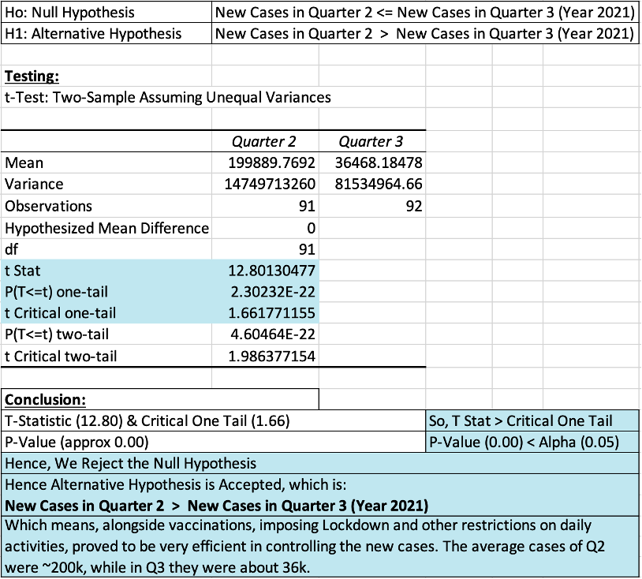

Visual Analysis:

From the below visual, we can see the trends of the increasing and falling of the cases and deaths. It also helps to prove the credibility of the Lockdown Effect test.

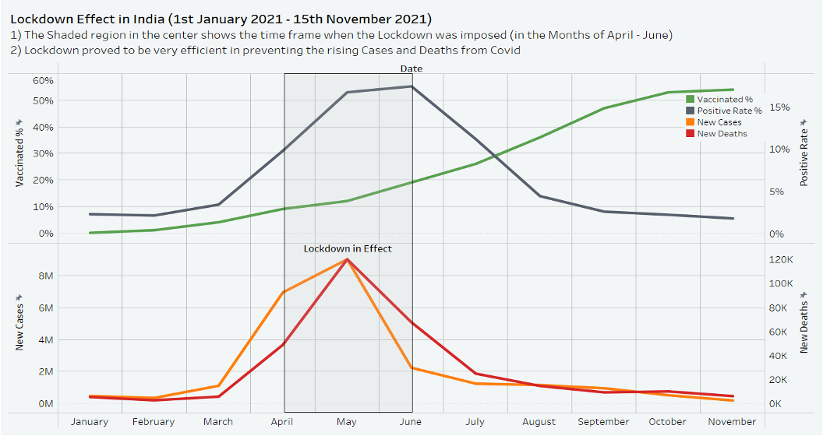

The cases were suddenly increasing in the month of March, and were reaching peak, and during the period when lockdown was imposed, the cases and deaths both were at peak.From that point forward, throughout May and June, the number of new cases and deaths decreased. By the third quarter, cases and deaths appeared to be under control. In addition, vaccinations were administered, and the positive rate was progressively declining.

Therefore, Lockdown seems to have a positive effect in mitigating the impact of covid-19.

**Inference and Recommendation:**

1. The preventive measures taken did abate the impact of Covid-19.
2. With Vaccinations provision, there is a great decline in the number of new cases and deaths as compared to the previous period.
3. Positive rates appear to have dropped dramatically as more people got vaccinated..
4. The imposition of Lockdown has proved out to be very efficient in halting and controlling the spread of Covid-19 virus.
5. Hence, in conclusion & recommendation we can say that, as more population gets vaccinated, the cases, deaths and positive rate will gradually decrease over time.
6. And, Lockdown restrictions will also aid in preempting the widespread of Covid-19 virus whenever there are chances of sudden peak or outbreak.